**Bobby's Bio**

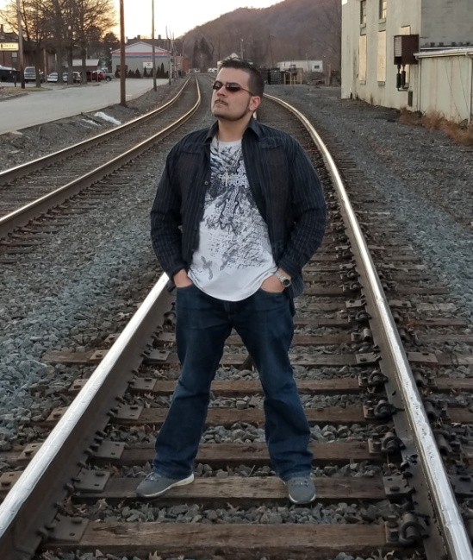The first time Bobby Blaze revealed his talent, his musical skills were recognized immediately. Freestyling was something he did just for fun at parties and gatherings, but those who were exposed to his lyricism and remarkable word constructions, not to mention his exciting delivery, a mesmerizing blend of tempo and rhythm spoke to Bobby the catalyst for the creation of a new star. His listeners told him his talent was being wasted as long as he kept it as an among-friends thing at social events. And they were right. Now, Blaze has recently released his latest album entitled "The Prodigal Son" which is virtually his testimony set to urban music. Bobby opens up like he never has before about personal life struggles and adversities as he tells these stories set to Hip-hop, R&B, soul and Gospel.  
  
The real communication that goes on within music is an endless cycle between artist and listener. The listener receives the full gift of music when he devotes his full attention to it and appreciates its levels. But it requires the best in songwriting to dominate a fan's attention. So it's the artist's responsibility to pull in the listener with refined talent and the sharpest creativity. "The musical undertone of any song can control the emotion of the listener, depending on how intently he listens," says Blaze. "The emotion I feel when I listen to music depends on the way the artist portrays the thought they put into the music as a whole." Listener and artist both have to devote themselves to the music for its full impact to become known. And Blaze is certainly doing his part...  
  
Success in the music industry is important to most artists, and Blaze is no different. But he believes there are deeper motivations to music than just industry success. Talents are given for a reason, artistic or otherwise. And all talents are for the bettering of people everywhere. For Blaze, that means that he, as a musician, has an obligation to pour his all into his music and to dig deep and find something truly important to say. Hacks waste their gifts, and Blaze is no hack. "It is the responsibility for any truly talented artist to use the musical gifts given to them by God to better humanity. In these days when the musical mainstream is flooded with artists who have no true talent in writing or concept design, they are strictly an image with no intelligence or wisdom. This day in age it is more important than ever to spread positivity and share hope with those who feel hopeless."  
  
Blaze has shared the stage with Hip Hop icons like Bone Thugs N Harmony and Gospel artists like Howard Hewett as well as many local and regional acts. When not on stage, he's always got his fingers in writing, recording and the development of new concepts to further his art. Blaze has also collaborated with artists from across the globe with his music heard on the international stage.

For more info...

E-Mail: BobbyBlaze412@gmail.com

Phone: (724) 797-1191

Web: BobbyBlaze.com